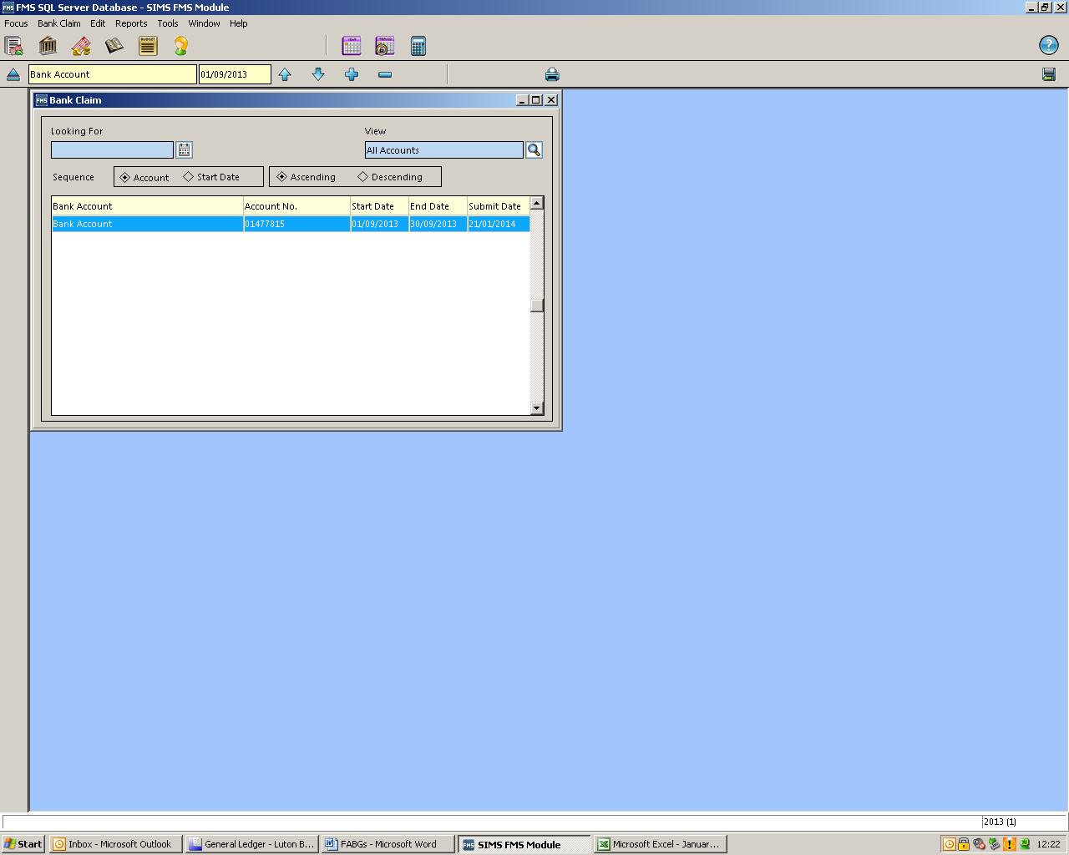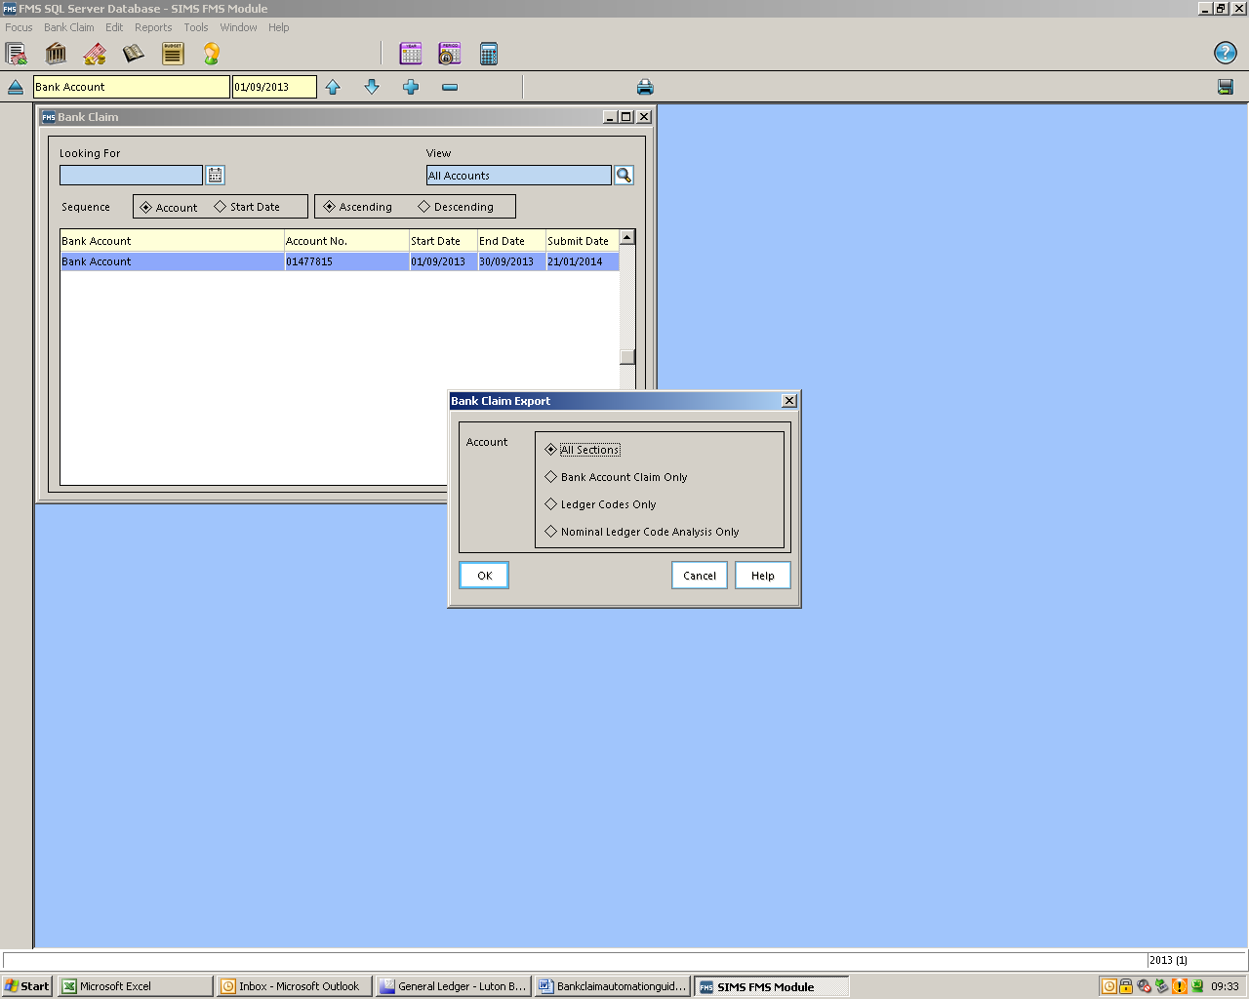

Run your bank claim as normal for the month, and print. After confirming that the print was OK, making sure that the latest bank claim is highlighted, click on the ‘export bank claim report to disk ’button, this can be found in the top right hand corner of the screen below the help button.

When you have done that you will see the following screen, choose ‘All Sections’ and click OK.

You will then see a screen where you can save the report. Name it for the relevant month (in our example January bank claim) click ‘Save’.

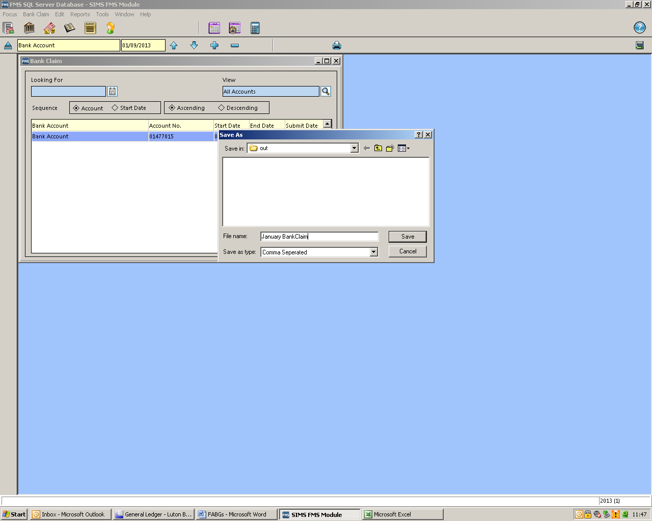

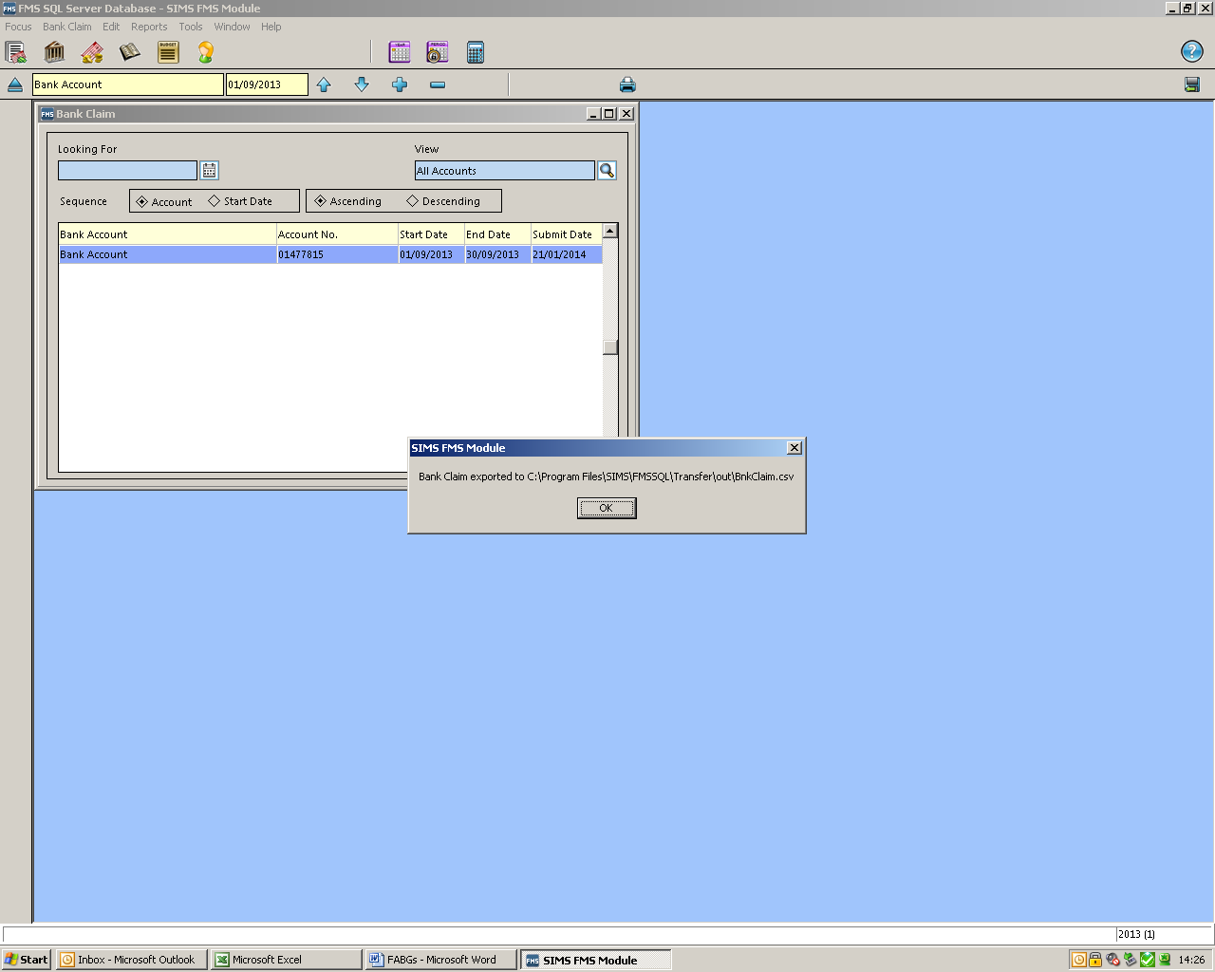

You will then see message telling you where your report has been saved. Make a note of this.

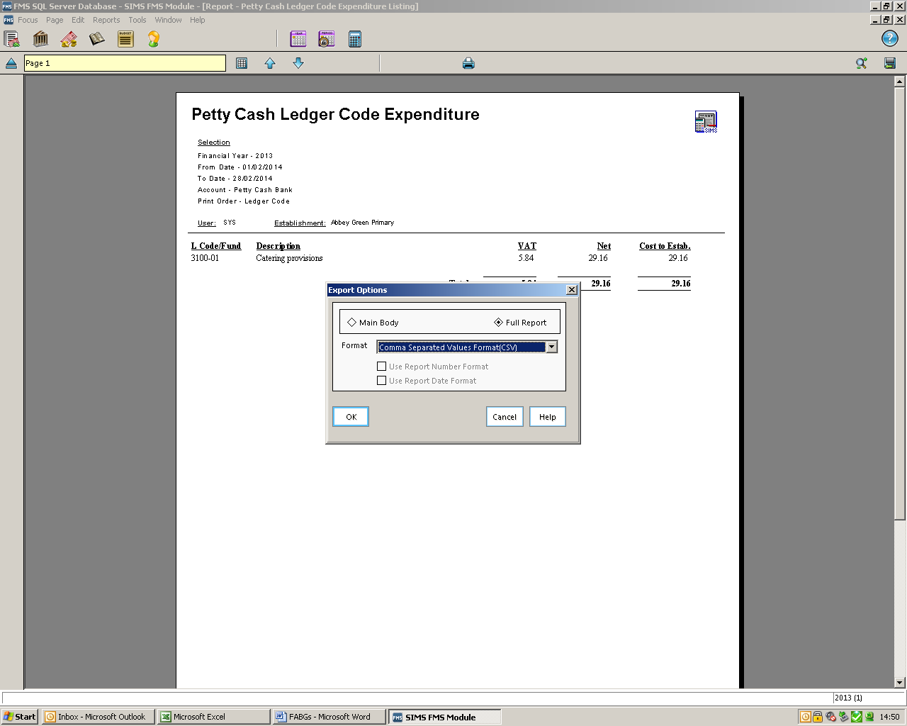

Run your petty cash report for the relevant dates and then click on the ‘Export to disk’ button top right of the screen. When the box below appears choose ‘Full Report’ and ‘Comma Separated Values Format’ click OK.

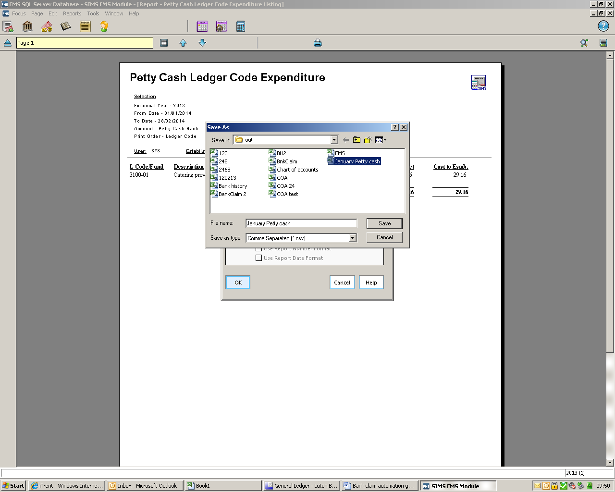

You will see a screen where you can save the report, the name will be the same month as the bank claim you have just produced. Save the report. Email the petty cash and bank claim report along with a scanned copy of the full bank reconciliation return to the LMS inbox (lms@luton.gov.uk).